Week 5: VPC Creation and Ec2 Instance Connection

🔹 Step 1: Create the VPC
- Go to AWS Management Console → VPC
- Click Create VPC
- Choose VPC only
- Enter:
  - Name: Custom-VPC
  - IPv4 CIDR block: e.g. 10.0.0.0/16
- Click Create VPC
- 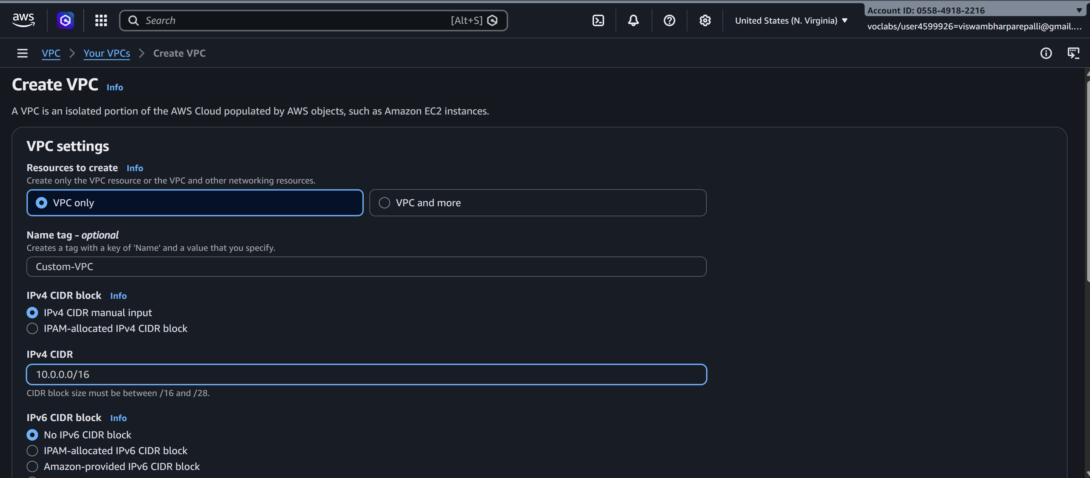
- 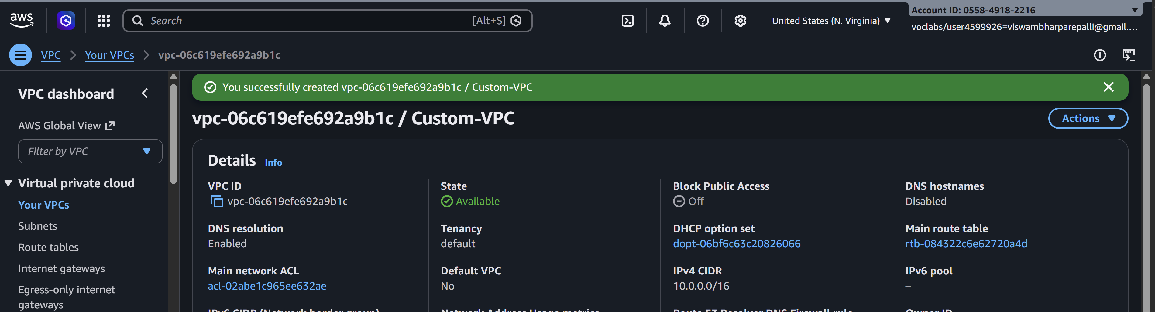

🔹 Step 2: Create Subnets (Public & Private)
Create subnets in same Availability Zones for high availability.

Example:
- Public Subnet: 10.0.1.0/24 (AZ-A)
- Private Subnet: (AZ-A)
Steps:
- Go to Subnets → Create subnet
- Select your VPC
- Choose AZ
- Enter CIDR
- Create subnet
- 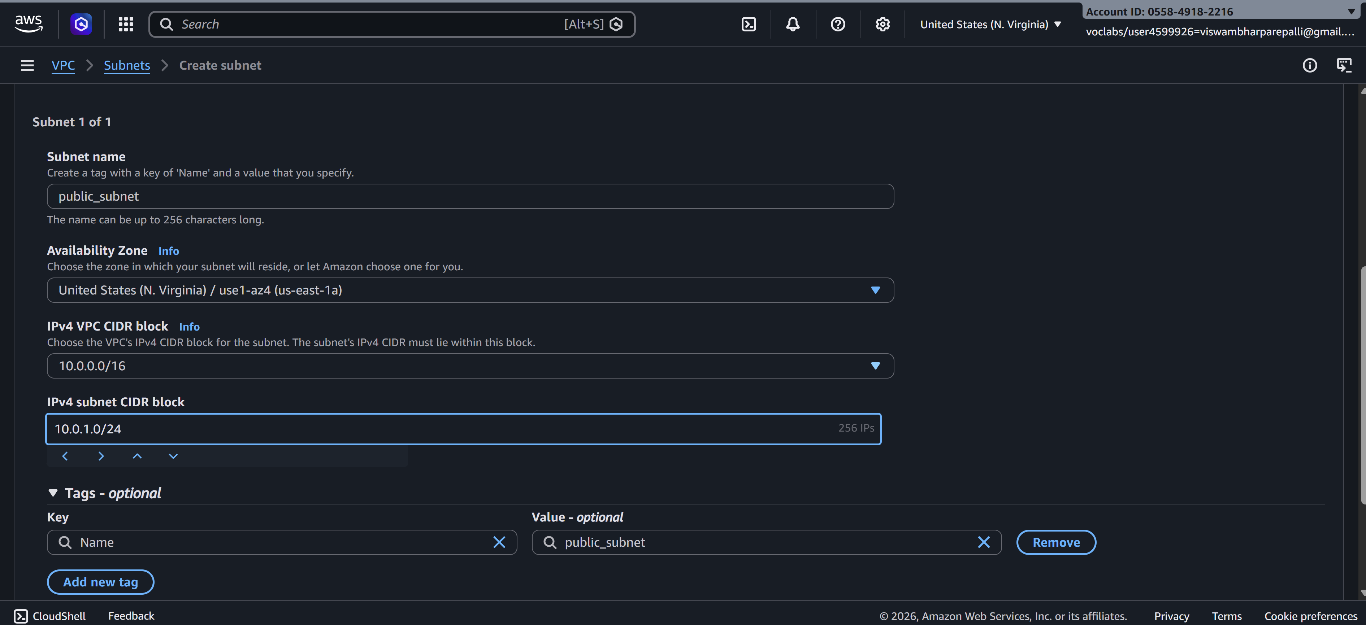
- 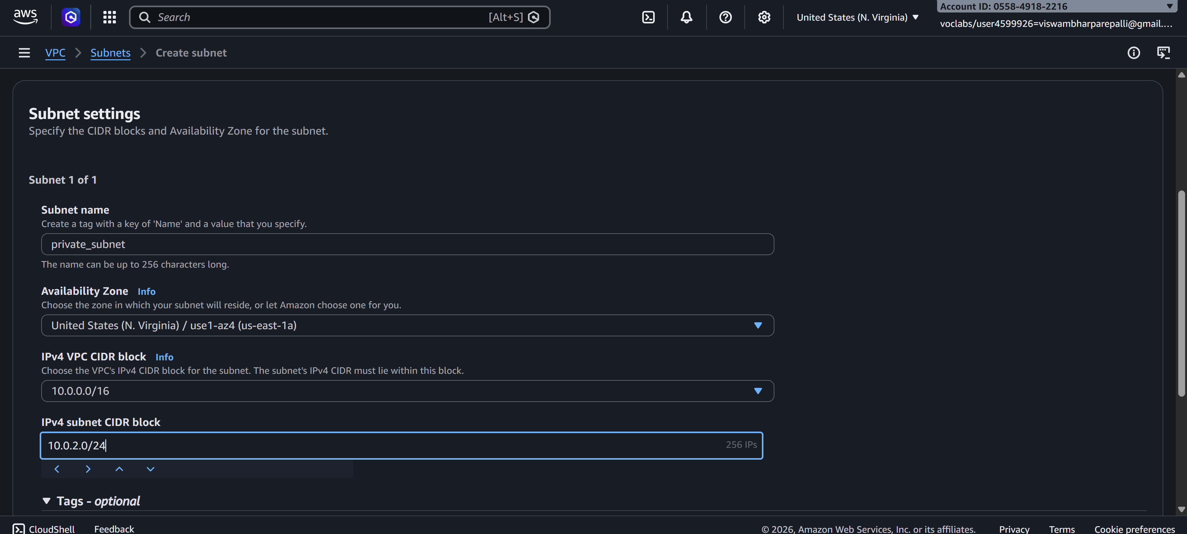

🔹 Step 3: Create an Internet Gateway (IGW)
- Go to Internet Gateways
- Click Create internet gateway
- Name it Custom-IGW
- 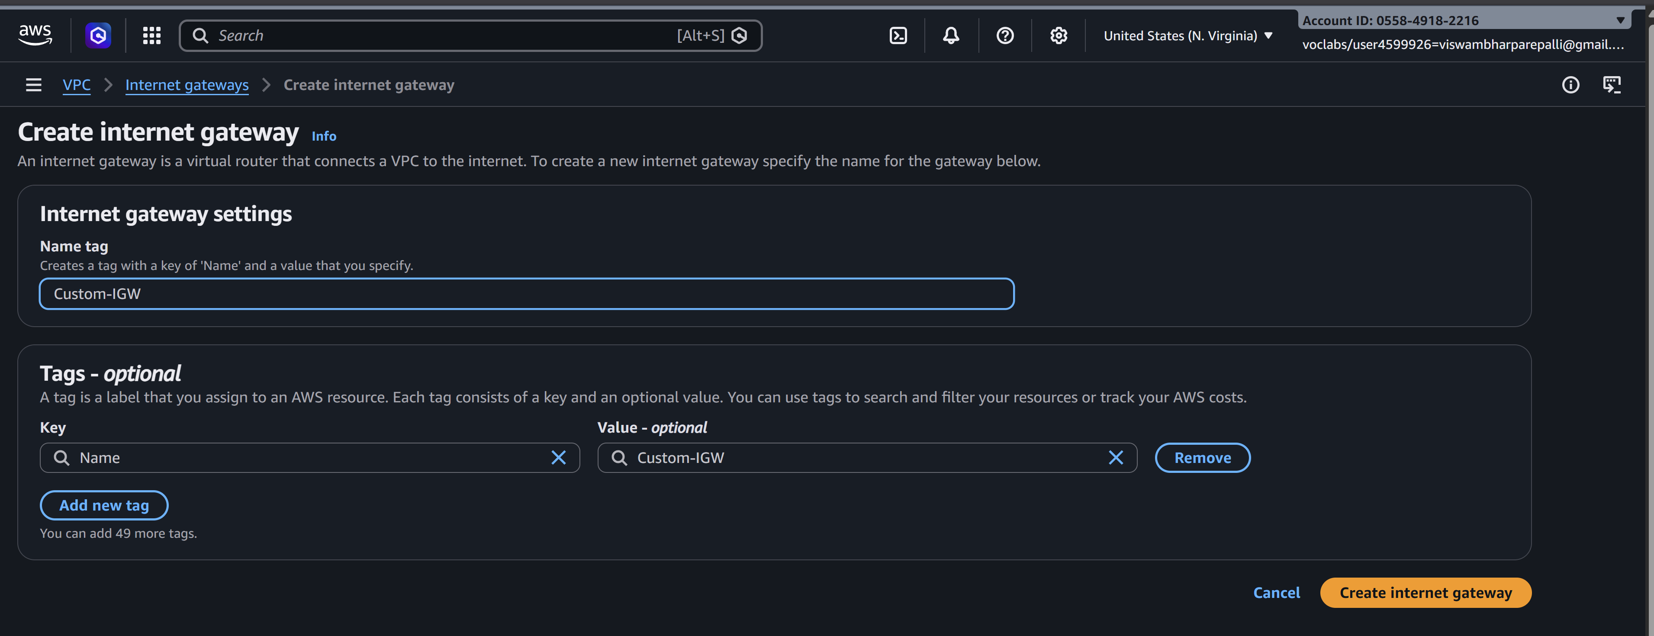
- Attach it to your VPC
- 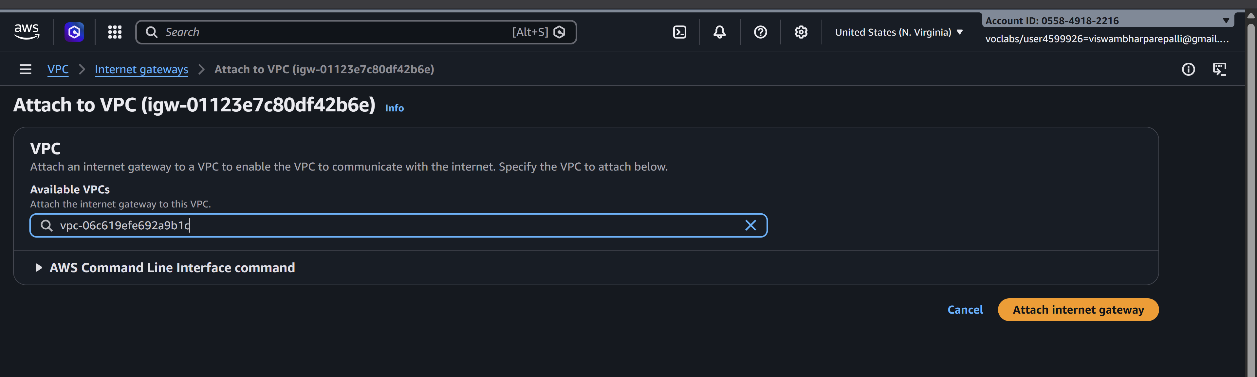

🔹 Step 4: Create Route Tables
You need separate route tables for public and private subnets.

Public Route Table
- Go to Route Tables → Create route table
- Select VPC
- 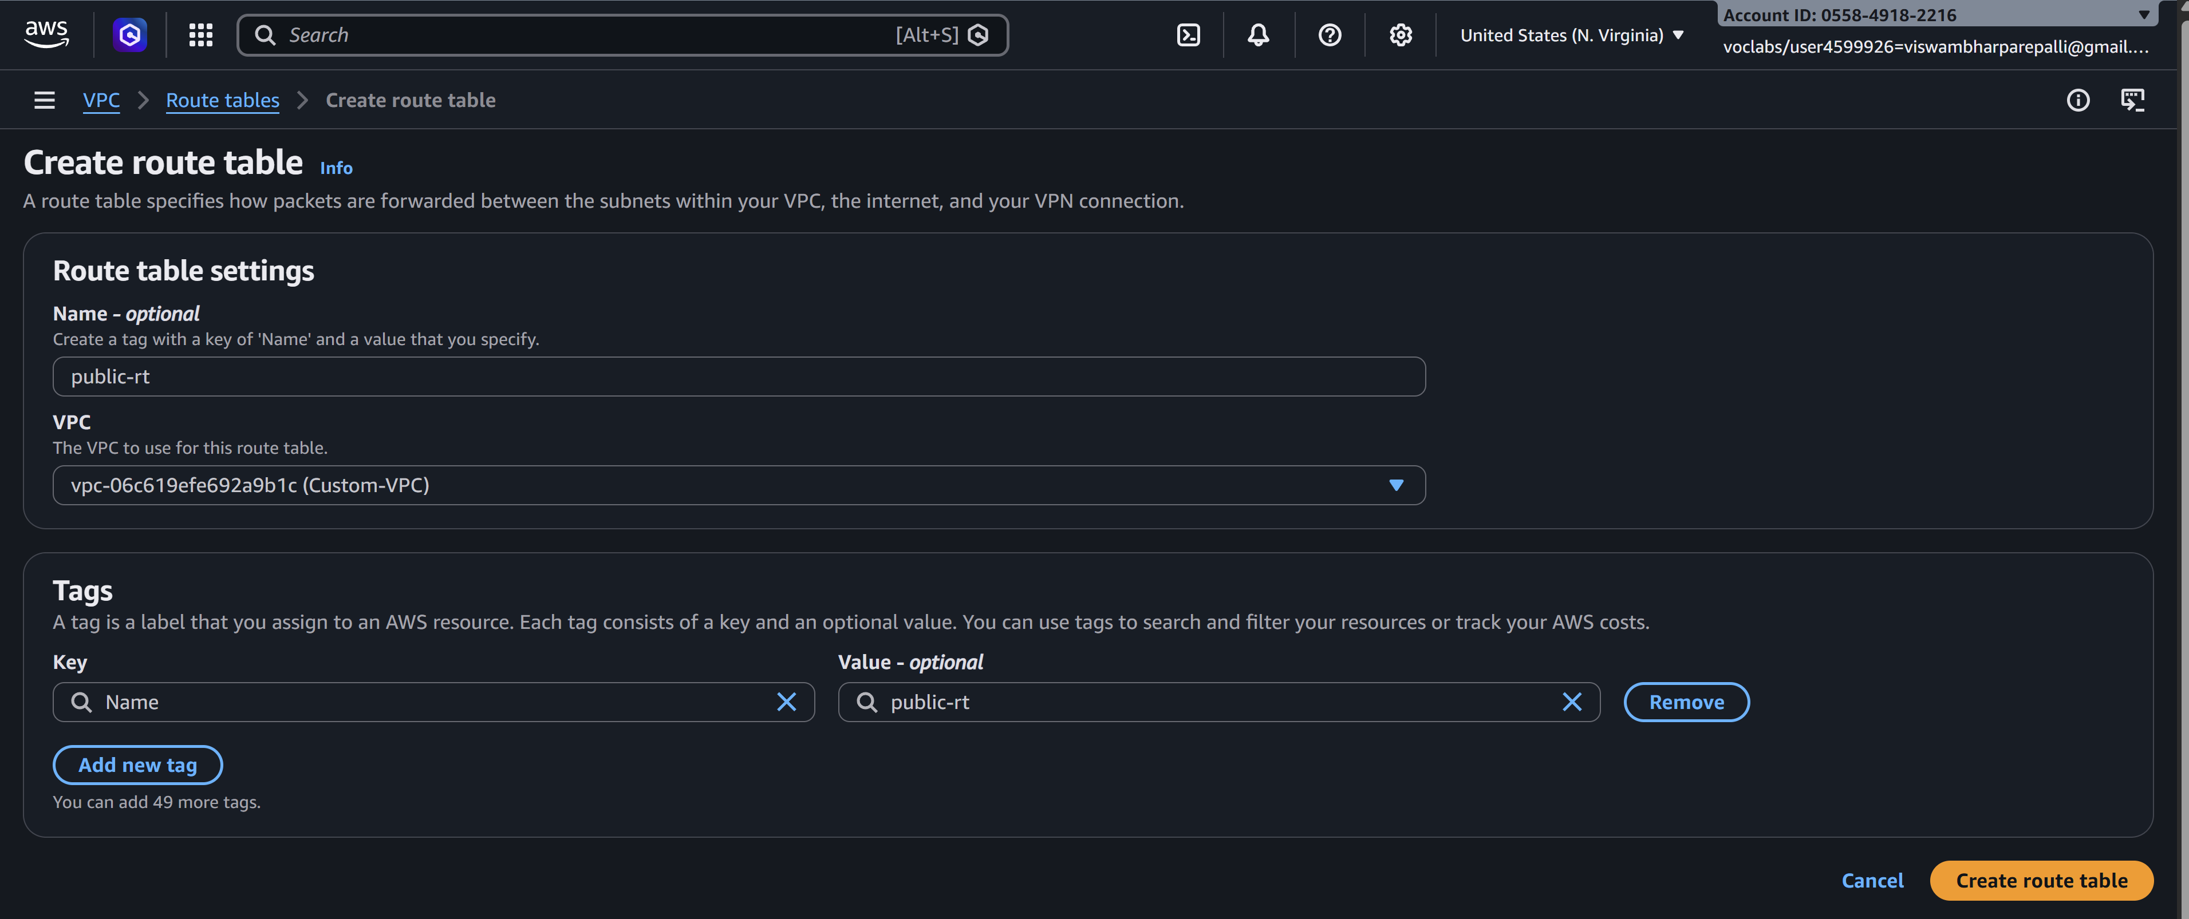
- Add route:
  - Destination: 0.0.0.0/0
  - Target: Internet Gateway
- Associate with public subnet
- 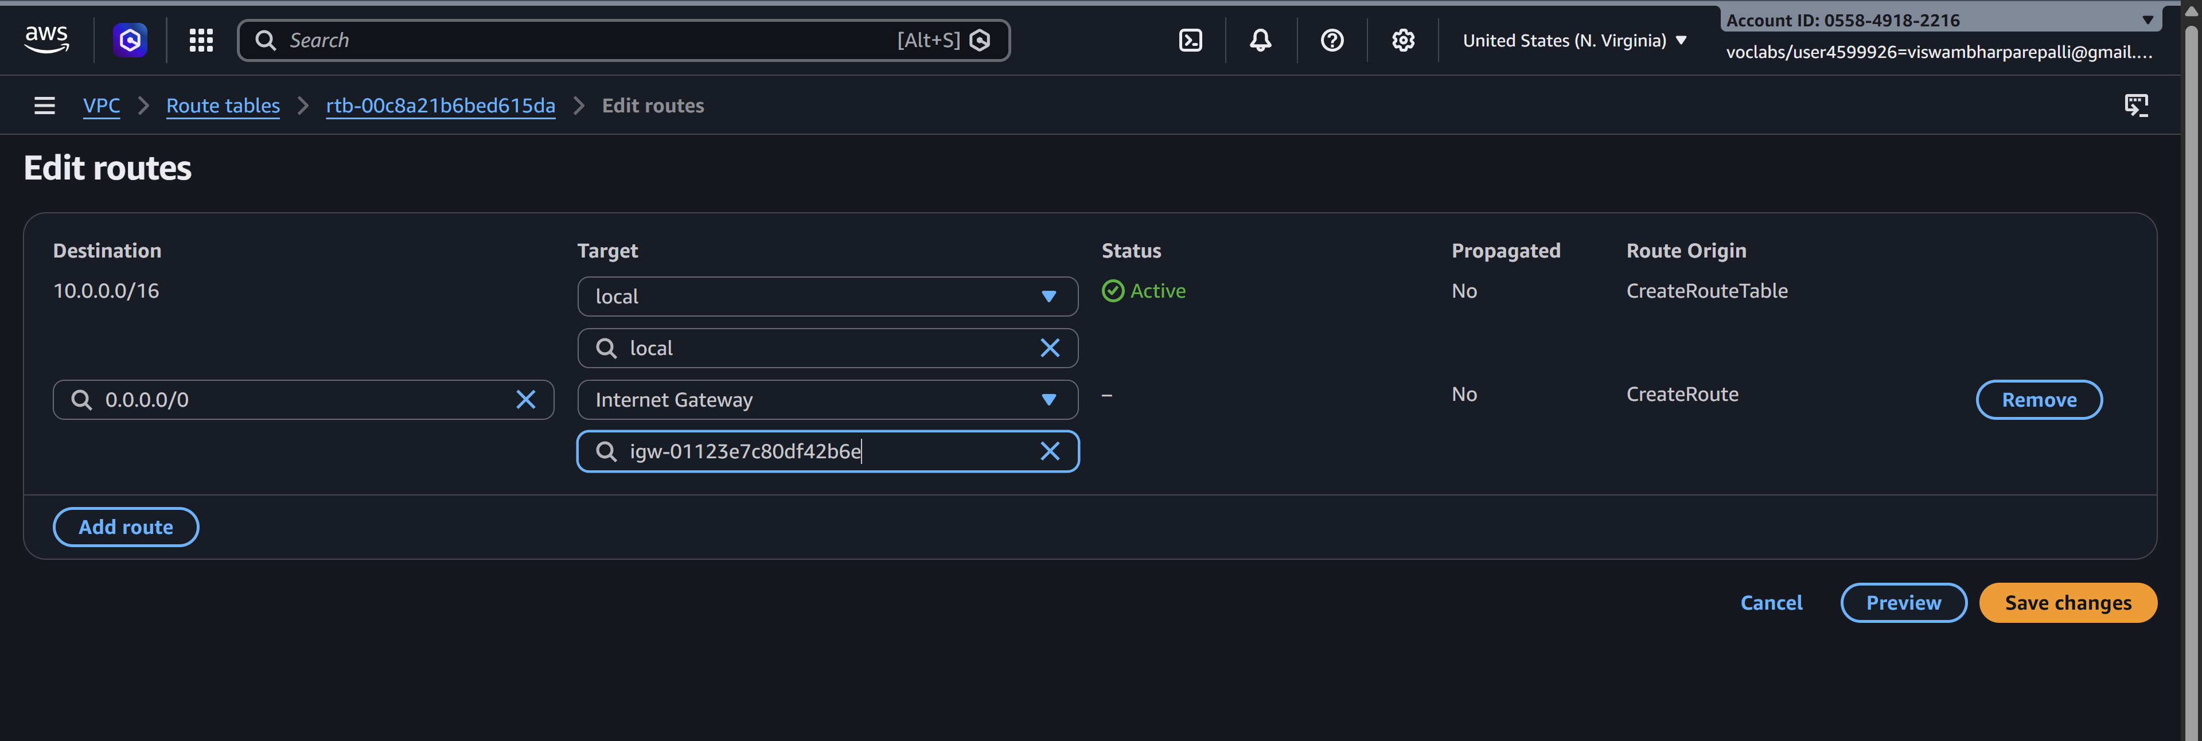
- 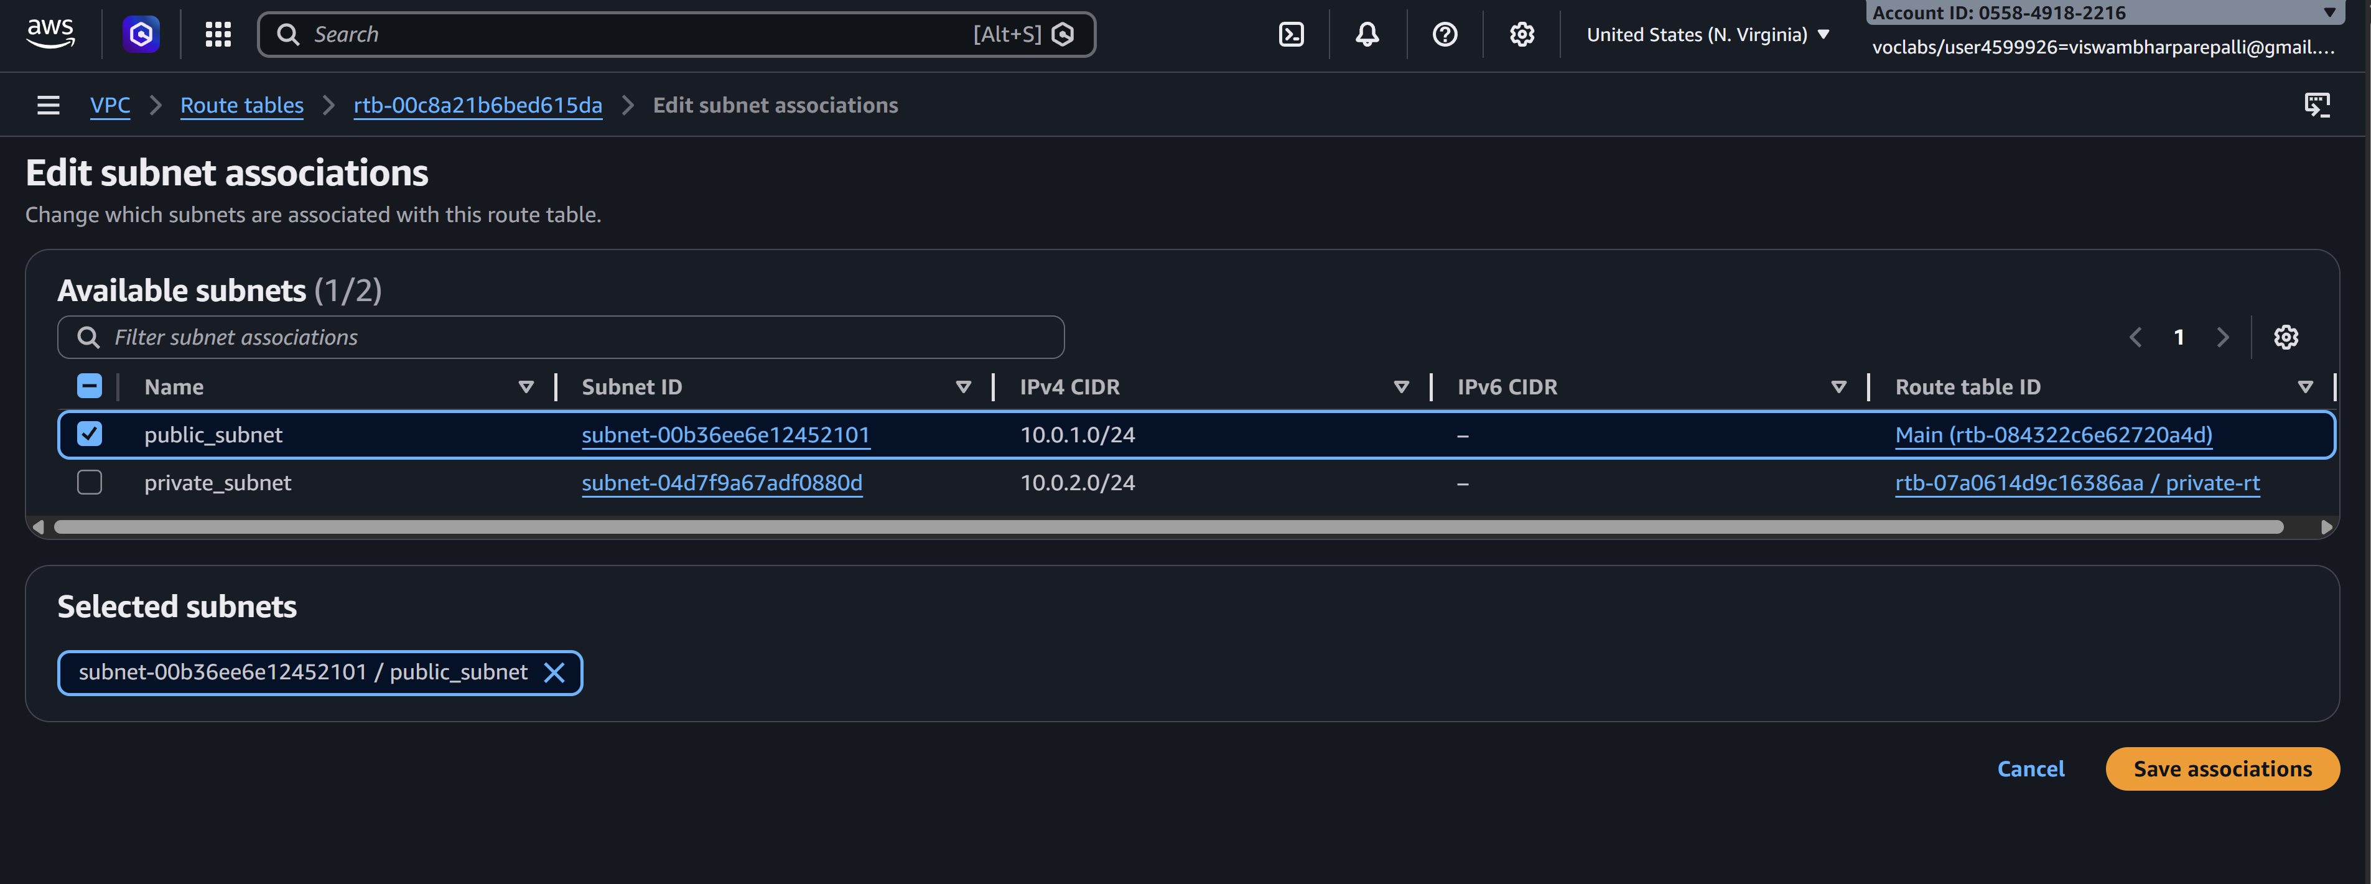

Private Route Table
- Keep default local route only (no IGW)
- Associate with private subnet
- 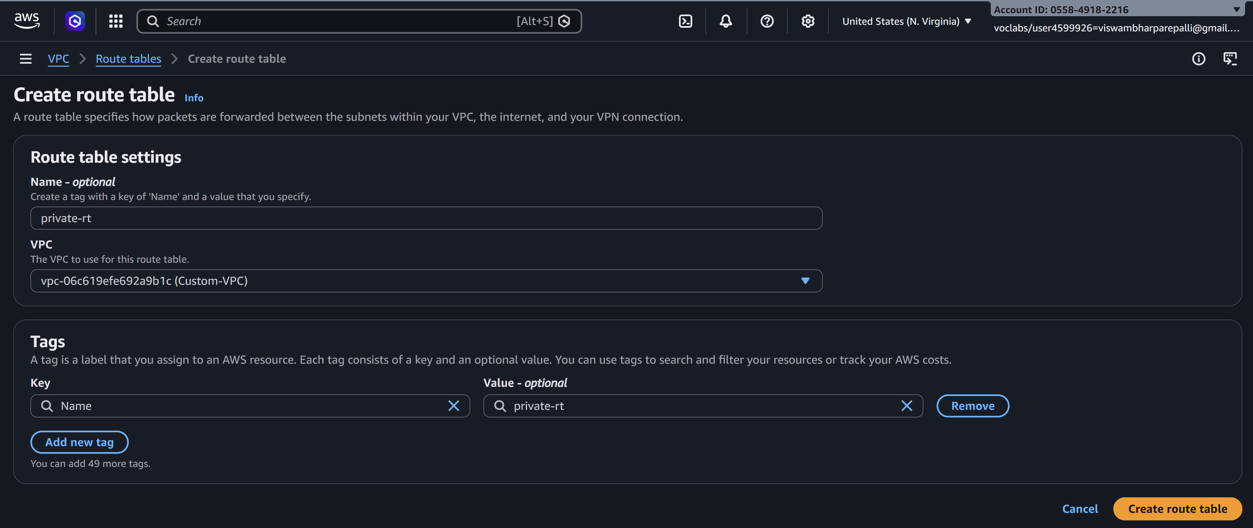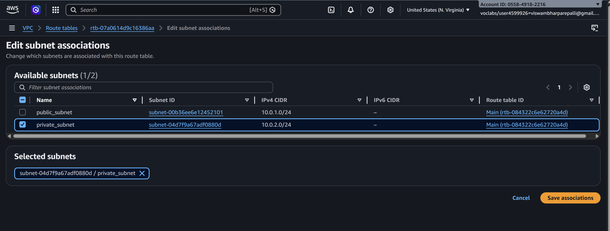

🔹 Step 5: Enable Auto-Assign Public IP (Public Subnet)
- Select Public Subnet
- Go to Edit subnet settings
- Enable Auto-assign public IPv4 address

- 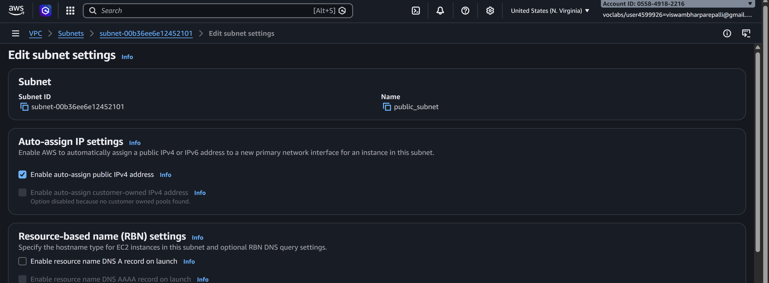

🔹 Step 6: Configure Security Groups
- Create a Security Group
- 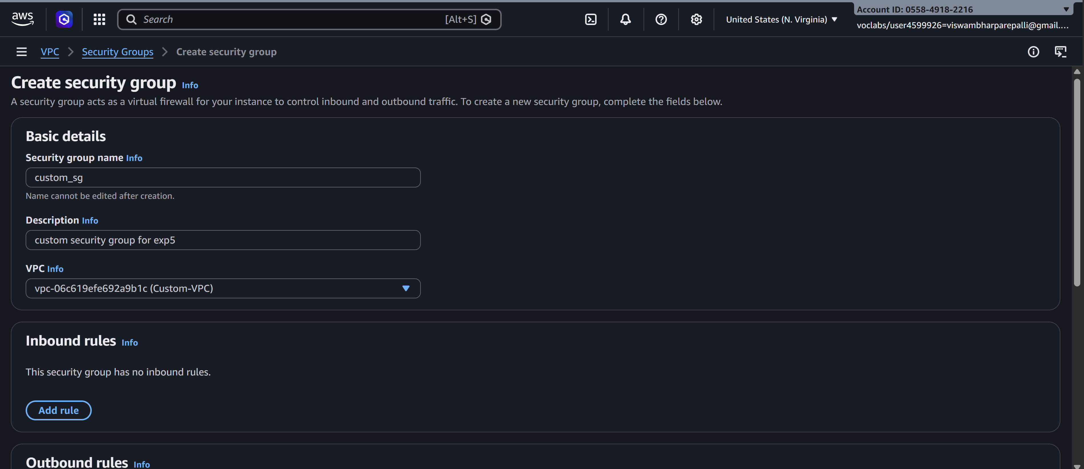
- Add inbound rules:
  - HTTP (80) / HTTPS (443)
  - SSH (22) from trusted IP
  - 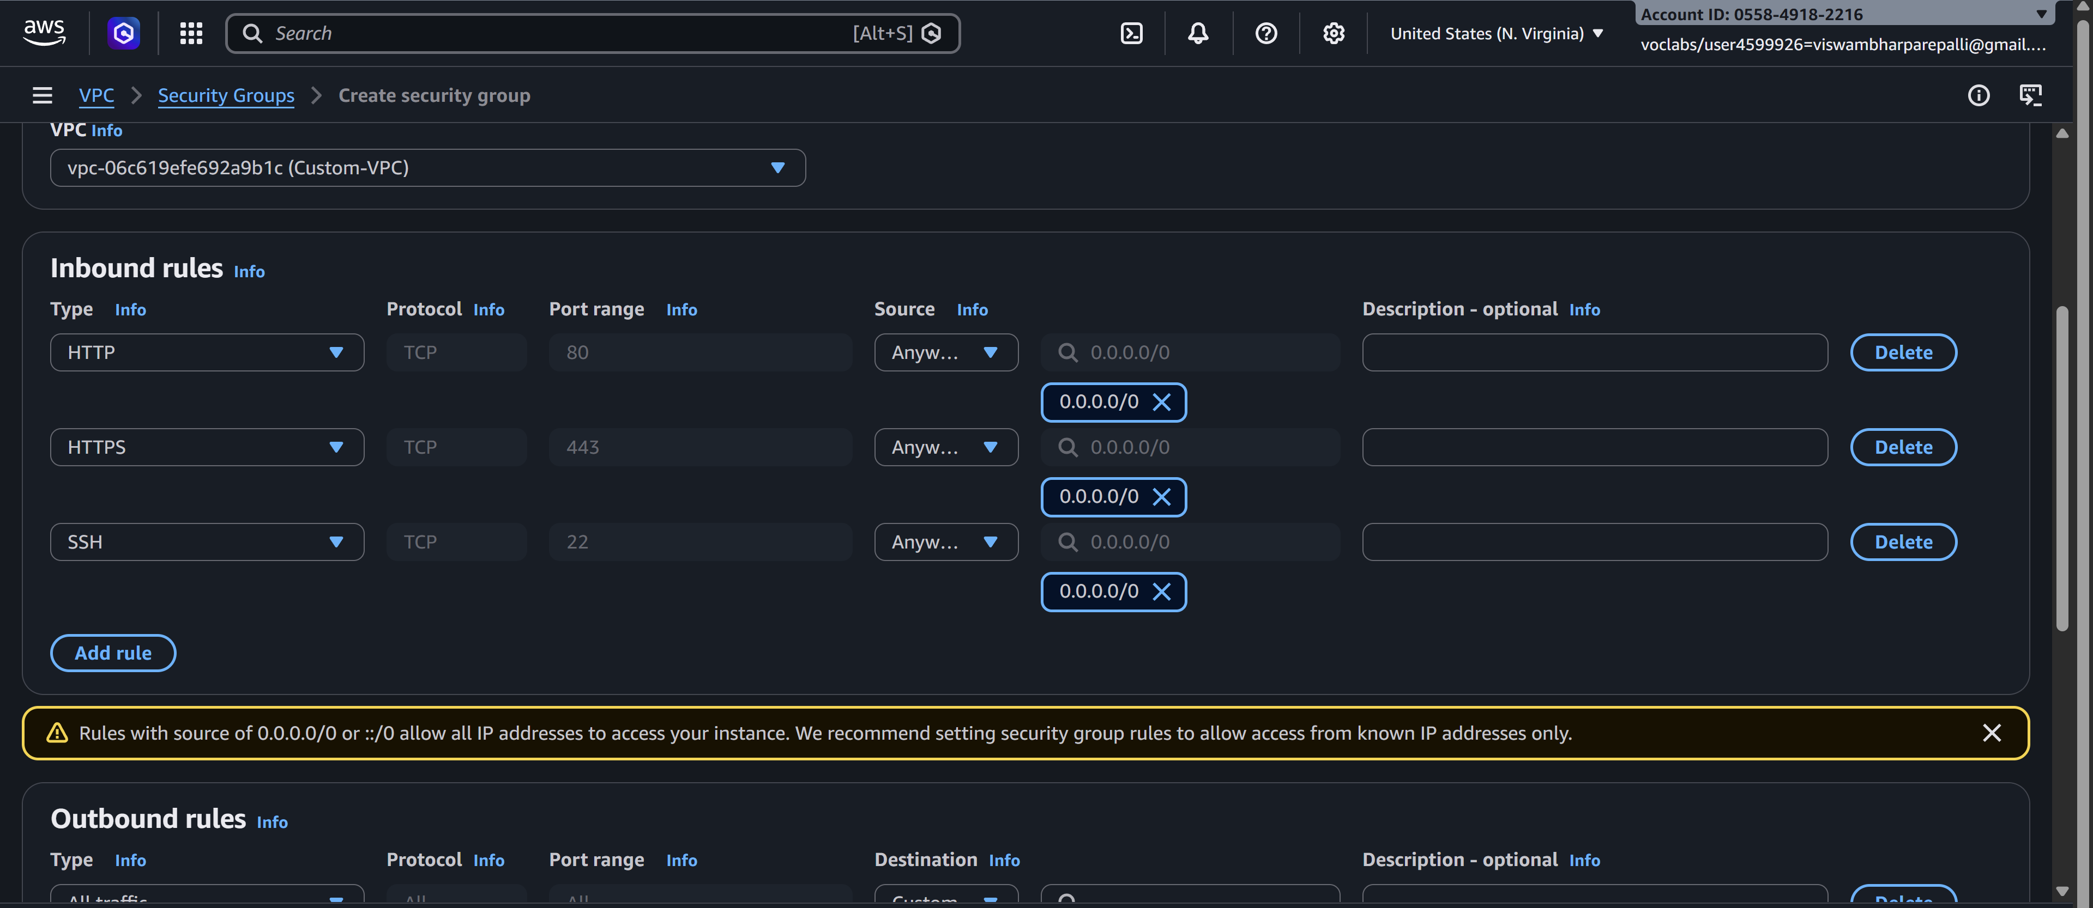
- Attach to EC2 instances

🔹 Step 7: Launch EC2 Instances
- Public EC2 → Public subnet
- 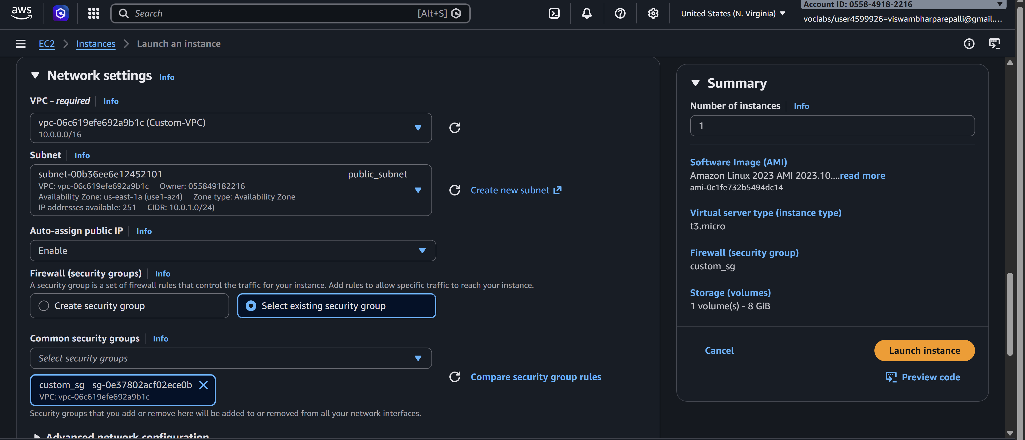
- Private EC2 → Private subnet
Attach correct security groups.
- 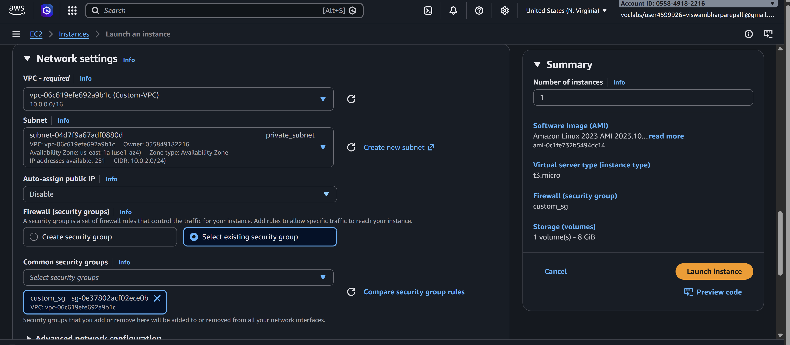

🔹 Step 8: Test the Setup
- Public EC2 → Internet access ✔
- 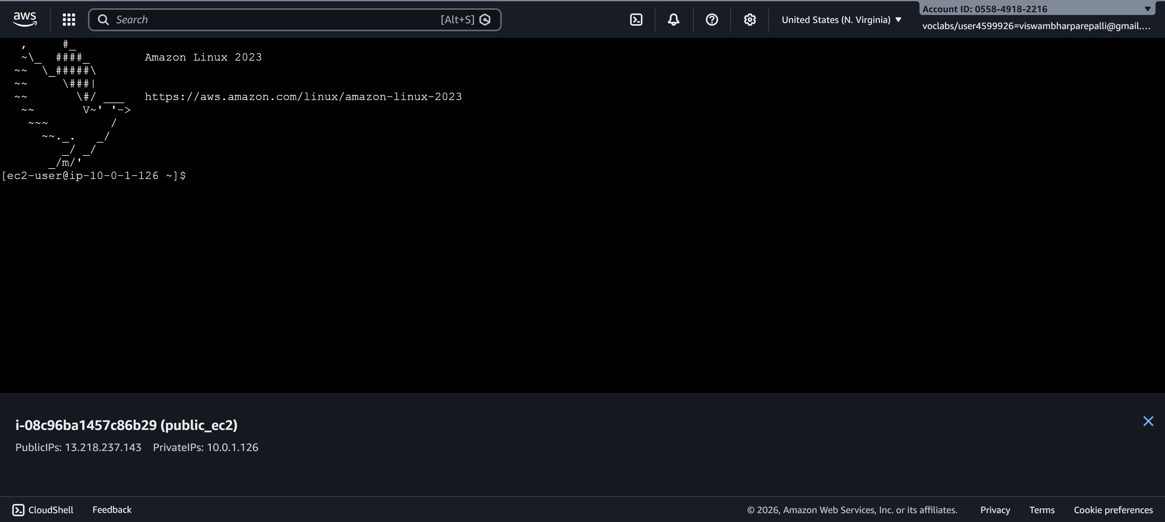
- Private EC2 → Internet via NAT ✔
- Private EC2 → No direct inbound access ✔
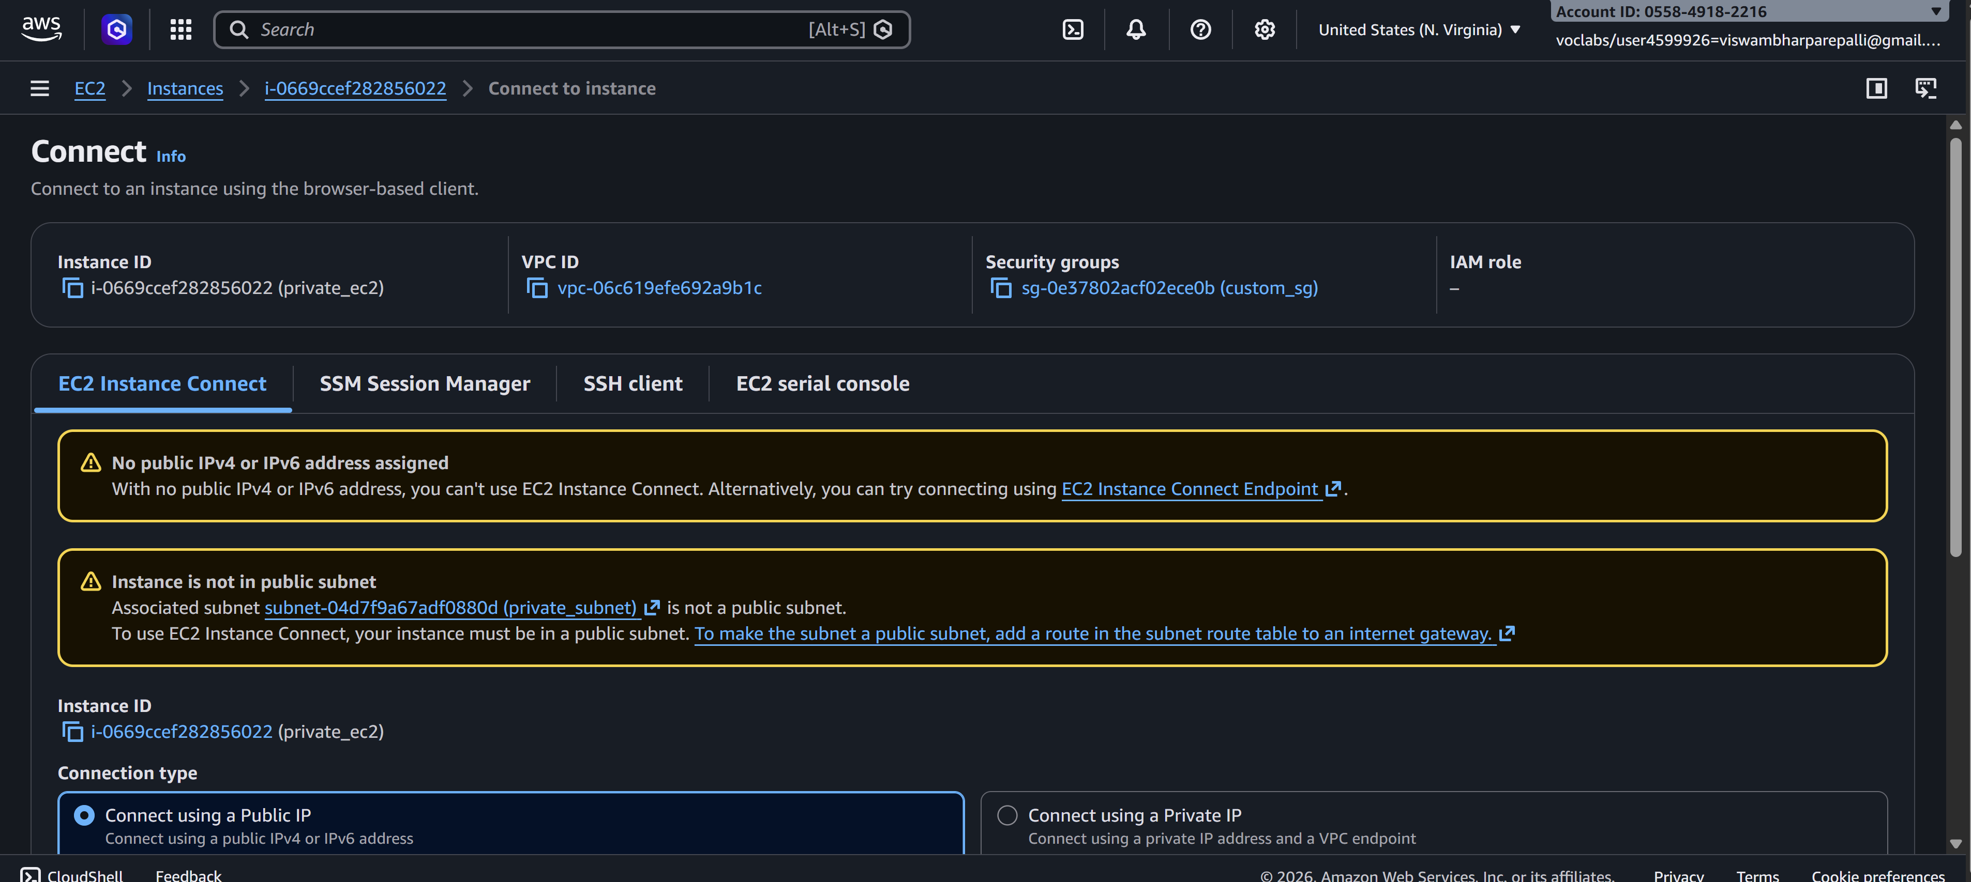

Scenario Based Questions:

- You have a web application where users access a website, but the database should not be exposed to the internet. How would you design the VPC? Which resources go into public and private subnets?
Answer:
Use a layered subnet design:
- Public subnets: Internet-facing Application Load Balancer, NAT Gateway, Bastion host (if needed).
- Private subnets: Web/App servers and RDS database.
Attach an Internet Gateway (IGW) to the VPC. Public subnets route 0.0.0.0/0 → IGW. Private subnets use NAT Gateway for outbound internet. Database stays isolated with no public IP.

- An EC2 instance in a public subnet cannot access the internet. What VPC components would you check and why?
Answer:
Check in this order:
- Internet Gateway attached to VPC.
- Route table: 0.0.0.0/0 → IGW.
- Instance has public IP or Elastic IP.
- Security group outbound rules.
- NACL outbound rules.
- Source/Destination check (if NAT/bastion).
Most failures are missing public IP or wrong route table.

- Your application server needs to connect to an RDS database securely. How would you configure security groups and subnets?
Answer:
- Place RDS in private subnets (no public access).
- App servers in private or public subnets depending on architecture.
- Create separate security groups:
  - App SG: allow outbound DB port.
  - RDS SG: allow inbound DB port only from App SG (not CIDR).
This enforces least privilege and avoids exposing DB publicly.

- You are asked to design a VPC for 500 servers today, but it should scale to 2,000 servers in the future. How would you choose the CIDR block?
Answer:
Plan for future growth:
- 2,000 instances require far more IPs due to scaling buffers, ALBs, RDS, Lambda ENIs, etc.
- Choose something like /16 CIDR (e.g., 10.0.0.0/16) instead of /24 or /20.
AWS reserves 5 IPs per subnet, so larger CIDR prevents painful re-architecture later.

- A company wants secure connectivity between its on-premises data center and AWS VPC. Which AWS services would you choose and why (VPN vs Direct Connect)?
Answer:
- Site-to-Site VPN: Fast to deploy, encrypted over internet, lower cost. Good for quick setup or moderate traffic.
- Direct Connect: Dedicated private link, predictable latency, high bandwidth, no internet exposure. Best for production hybrid workloads.
Often companies use Direct Connect + VPN backup.

- You need to connect two VPCs, but both use the same CIDR range. How would you solve this problem?
Answer:
VPC peering and Transit Gateway don’t support overlapping CIDRs. Options:
- Re-IP one VPC (best long-term solution).
- Use NAT Gateway or proxy-based routing.
- Use PrivateLink if only specific services need exposure.
Overlapping CIDRs are a design mistake — avoid them early.

- Multiple microservices running in different subnets need to communicate securely. How would you design routing and security groups?
Answer:
- Keep default local route in route tables for intra-VPC communication.
- Use security-group-to-security-group rules, not wide CIDR rules.
- Separate SG per service (e.g., ServiceA SG allows inbound only from ServiceB SG).
- Avoid opening entire subnet ranges unless absolutely necessary.

- Design a VPC for a 3-tier application (Web, App, DB) with high security and scalability. Explain subnets, route tables, gateways, and security groups.
Answer:
Architecture:
- Public subnets: ALB, NAT Gateway.
- Private App subnets: Application servers.
- Private DB subnets: RDS.
Routing:
- Public route table → IGW.
- App subnet route → NAT Gateway.
- DB subnet → no internet route.
Security Groups:
- ALB SG allows 80/443 from internet.
- App SG allows traffic only from ALB SG.
- DB SG allows DB port only from App SG.
Use multi-AZ subnets for high availability.

- You suspect unusual traffic inside your VPC. How would you monitor and analyze network traffic?
Answer:
- Enable VPC Flow Logs → CloudWatch or S3.
- Use CloudWatch metrics and alarms.
- AWS GuardDuty for threat detection.
- Traffic Mirroring for deep packet inspection if needed.
Flow logs are usually the first step.

- Why can’t a private subnet have an Internet Gateway directly attached?
Answer:
Internet Gateways attach to the VPC, not individual subnets.
A subnet becomes “public” only when its route table sends traffic to the IGW. Private subnets intentionally avoid that route for security isolation.

- What happens if route tables are misconfigured in a VPC?
Answer:
Traffic gets dropped or blackholed:
- Instances lose internet access.
- Services cannot reach each other.
- Load balancers fail health checks.
Routing issues often look like application failures but are network-layer problems.

- What happens if a route table has no local route?
Answer:
In AWS you cannot remove the local route — it is automatically added.
If hypothetically missing, resources inside the same VPC couldn’t communicate across subnets.

- An EC2 instance allows traffic on port 80 in the security group, but traffic is still blocked. What could be the reason?
Answer:
Common causes:
- NACL blocking inbound/outbound.
- Wrong route table.
- Instance has no public IP.
- Web server not running or listening.
- OS firewall (iptables/Windows firewall).
Security group alone doesn’t guarantee connectivity.

- You need to create a VPC that will host 1,000+ EC2 instances across multiple AZs. How do you decide the CIDR block?
Answer:
Estimate future IP usage, not just EC2 count:
- Include scaling buffers, load balancers, RDS, endpoints.
- Use /16 or /17 CIDR to avoid fragmentation.
- Pre-plan subnet ranges per AZ (e.g., /20 per tier per AZ).

- Only a company’s corporate IP should be able to SSH into EC2 instances. How would you implement this securely in AWS VPC?
Answer:
- In EC2 security group inbound rule:
  - Allow TCP 22 from corporate public IP CIDR (e.g., 203.x.x.x/32).
- Prefer bastion host or AWS Systems Manager Session Manager to avoid exposing SSH directly.

- An EC2 instance can send traffic out but cannot receive responses. Which VPC component might be misconfigured and why?
Answer:
Likely issues:
- Network ACL blocking inbound ephemeral ports (stateless).
- Asymmetric routing.
- Security group missing inbound rule for return traffic (less common because SGs are stateful).
- NAT Gateway/instance misconfiguration.
NACLs are the usual culprit because they require explicit inbound and outbound rules.

